**Xiangqi(Chinese chess)**

* **History**

Xiangqi (Chinese: 象棋; pinyin: xiàngqí), also called Chinese chess, is a strategy board game for two players. It is one of the most popular board games in China, and is in the same family as Western (or international) chess. Besides China and areas with significant ethnic Chinese communities, xiangqi (cờ tướng) is also a popular pastime in Vietnam.

* **Rules**

The game represents a battle between two armies, with the object of capturing the enemy's general (king). The advisors start on either side of the general. They move and capture one pointdiagonally and may not leave the palace, which confines them to five points on the board.Elephants are located next to the advisors. These pieces move and capture exactly two points diagonally and may not jump over intervening pieces; the move is described as being like the character ‘田’. If an elephant cannot move due to a diagonally adjacent piece, it is known as "blocking the elephant's eye".Distinctive features of xiangqi include the cannon (pao), which must jump to capture,a rule prohibiting the generals from facing each other directly; Horses begin the game next to the elephants, on their outside flanks. A horse moves and captures one point orthogonally and then one point diagonally away from its former position, a move which is traditionally described as being like the character “日”. The horse does not jump as the knight does in Western chess, and can be blocked by a piece located one point horizontally or vertically adjacent to it. The chariot moves and captures any distance orthogonally, but may not jump over intervening pieces.Each side starts with five soldiers. Soldiers begin the game located on every other point one row back from the edge of the river. They move and capture by advancing one point. Once they have crossed the river, they may also move and capture one point horizontally. Soldiers cannot move backward. Areas on the board called the river and palace, which restrict the movement of some pieces (but enhance that of others); and placement of the pieces on the intersections of the board lines, rather than within the squares.

The two players' pieces are usually colored red and black.Pieces are flat circular disks labeled or engraved with aChinese character identifying the piece type, and in a color indicating which player has ownership. The black pieces are marked with somewhat different characters from the corresponding red pieces.

* **Features**
* This is a desktop application, offline game.
* The program will have Player-Player mode
* The program may have Player-Computer mode, AI engine will use open source library and be modified (porting from other language, change API) to adapt this program
* The program will play by Xiangqi rule, there is a time counter for each player. When a chess piece is captured, it will be shown next to chess board. There will game history with standard notation from World XiangQi Federation.
* The UI will like this:

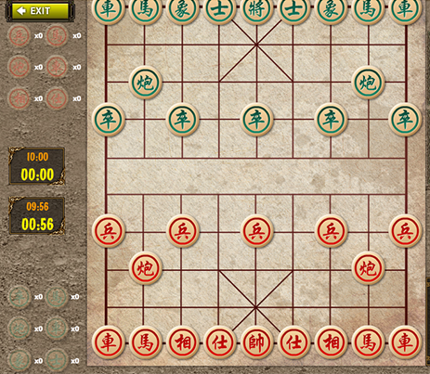

* **class diagram**

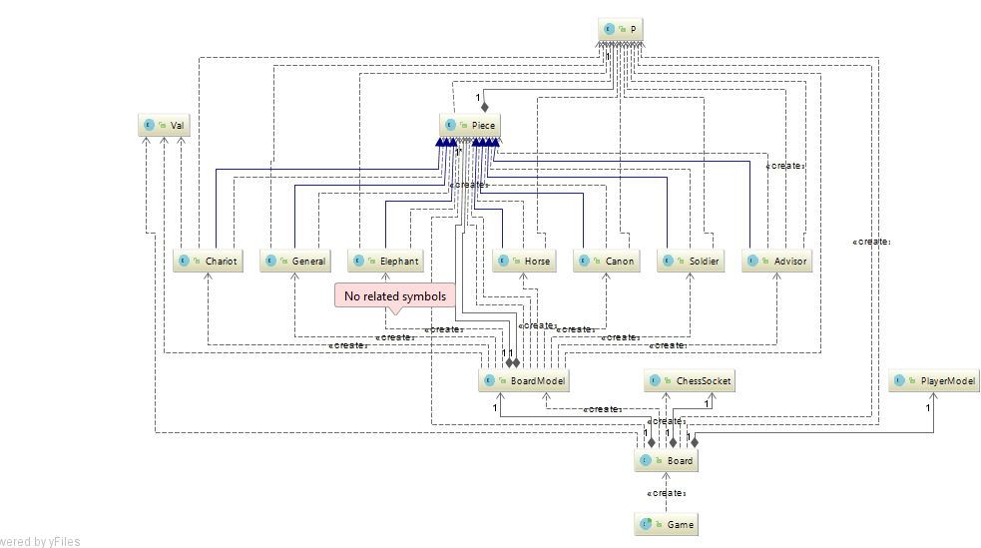

* **sequence diagram**

1.The first view of game is login.

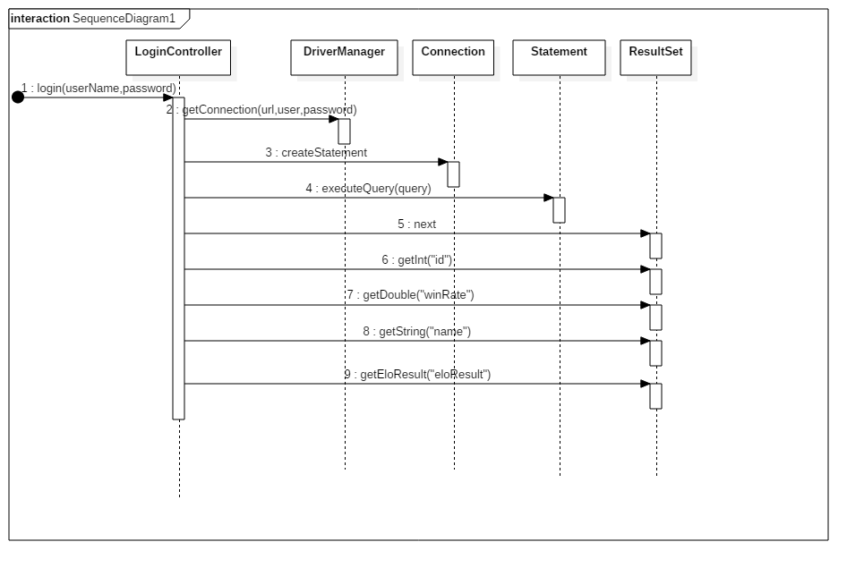

2.select PVC or PVP

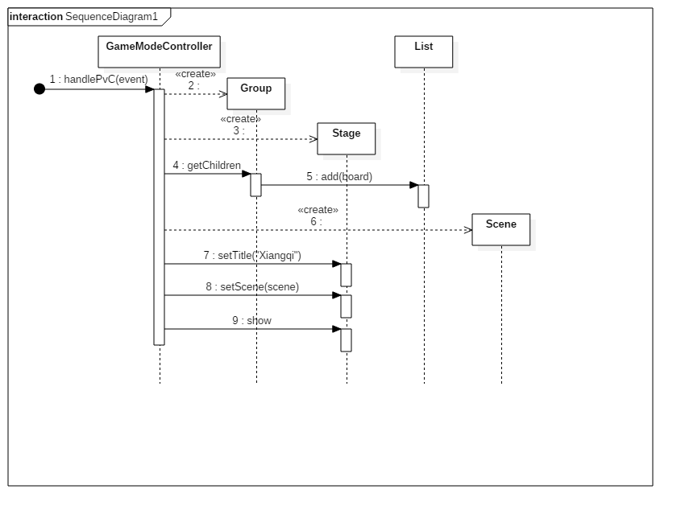

3.start game

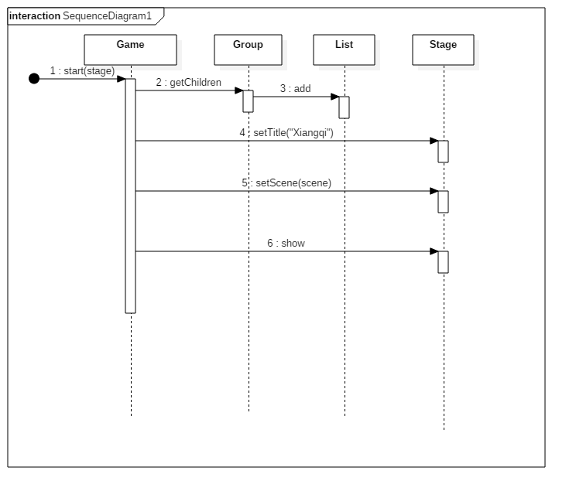

4.init game board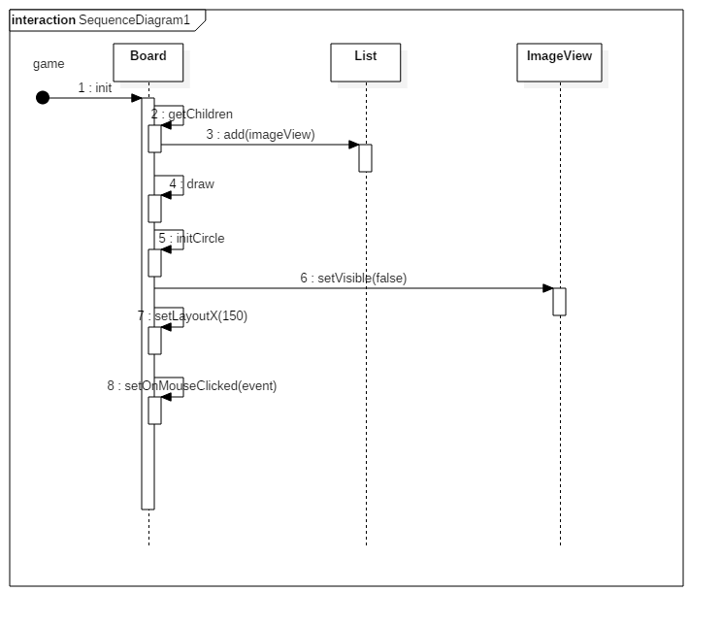

5.click chess

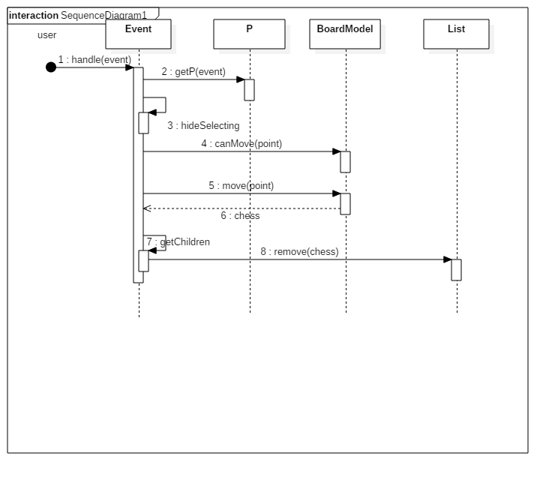

6.click no chess point, and if the pieces can pass the rule, then move.

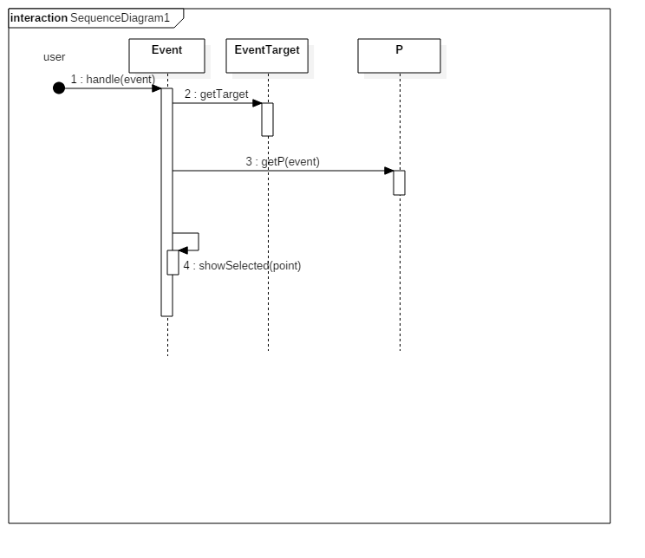

7.server sequence diagram

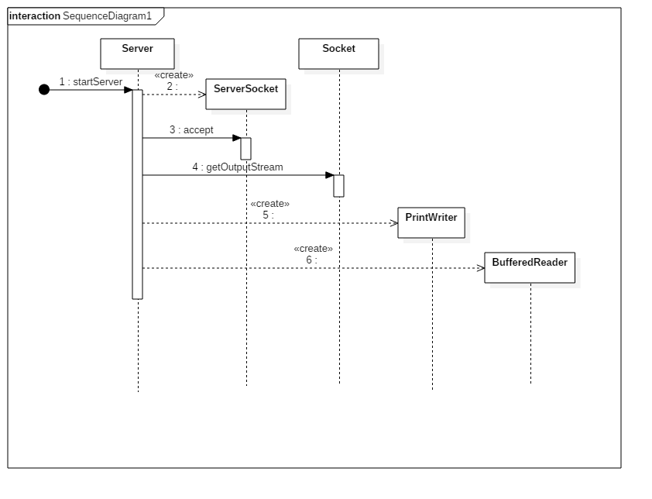

* **database**

We have a use table for users info:

**CREATE TABLE user(**

**`id` INT(5) NOT NULL AUTO_INCREMENT,**

**`name` CHAR(10) NOT NULL DEFAULT '',**

**`password` CHAR(10) NOT NULL DEFAULT '',**

**`winRate` INT (4) NOT NULL DEFAULT 0,**

**`eloResult` INT(8) NOT NULL DEFAULT 0,**

**PRIMARY KEY (`id`)**

**);**

We have create 10 test account, like test1,test2… password of all these accounts are 12345.

winRate is show you the percent of you games which you wins.

The eloResult is show your score of the xiangqi Game and it’s also the rank of this game.